Pokhara University

Level: Bachelor | Semester – Fall | Year : 2009
Programme: BE |  | Full Marks : 100
Course: Structural Analysis II |  | Time : 3hrs.

Candidates are required to give their answers in their own words as far as practicable.
The figures in the margin indicate full marks.

Attempt all the questions.

1. | - Determine the degree of static (external and internal) and kinematic indeterminacy of structure shown in fig.  - In a two hinged parabolic arch as shown in fig, determine the horizontal thrust due to given loading. One abutment is rigid but the other yields 0.001mm/kN of horizontal thrust. Include a rise in temperature of 12⁰C. Take EI_{C} = 2×10⁶ kNm² and α = 12×10⁻⁶/⁰C. | 4  11
2. | Determine the member forces of the truss as shown in fig 2 using consistent deformation method. Member BC and CF are 2mm too short whereas all horizontal members are subjected to temperature rise of 40⁰ C. Take E = 2×10⁵ N/mm² and α= 10.8×10⁻⁶/⁰C. | 15
3. | Analyse the continuous beam shown below by slope deflection method. The support B and C sink by 1cm and 0.5cm respectively and support D rotates through an anticlockwise angle of 0.2 radian. There are no loads on the beam. Values of E and I are constant through out length of the beam. Take E = 2×10⁵N/mm² and I = 4x10⁷ mm⁴. draw elastic curve and bending moment diagram.  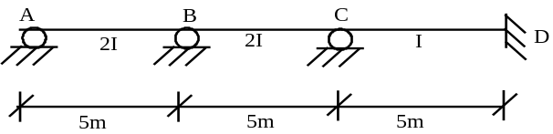 | 15
4. | Analyse the frame shown below using moment distribution method. Draw bending moment diagram.  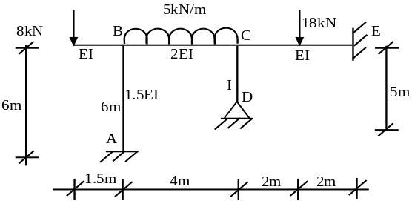 | 15
5. | - Determine the plastic moment capacity of the section required if the given loads in fig are the collapse loads. Assume the section is identical throughout.  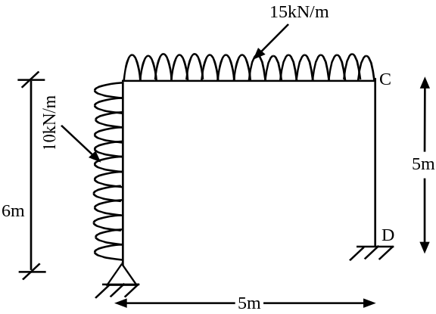  - Draw influence line diagram of reaction at B in the continuous beam shown in fig. The moment of inertia is constant. | 8  7
6. | Analyse the frame shown in figure using Stiffnes Matrix method. | 15
7. | Write short notes on (Any Two)  - Shape factor  - Lower bound and upper bound theorems  - Force and Displacement methods – compression | 5×2

